Course Name: | iOS App Development - SwiftUI | Semester: | VII
Date of Submission: | ___ / ___ / ______ | DIV/ Batch No:
Student Name: | Soumil Sinha | Roll No:

Mini Project Report
Title: OpenParliament — A SwiftUI Civic Transparency App for Tracking MPs, Bills and Budget Schemes, backed by a Local PostgreSQL Database

Abstract:
Parliamentary information — how often a member attends, which bills they sponsor, where a bill stands and how much of a scheme's budget was actually spent — is public but scattered across PDFs, gazette notifications and audit reports. OpenParliament brings these records together in a native iOS application written in SwiftUI.
The app has four tabs: MPs (searchable and sortable list, profile with an attendance chart, bills engaged with, speeches and committees), Bills (stage stepper, plain-language summary, dated progress, members who spoke, linked budget), Budget (allocation versus expenditure chart per financial year, utilisation and CAG audit notes) and Following (bills the user has chosen to track).
All records are stored in a normalised PostgreSQL database (17 tables, 3 enumerations, 3 derived views) and served by a small Node.js REST API. The app reads the full dataset in one request, keeps follows in sync with the database through optimistic updates, and falls back to a bundled offline dataset when the server is unreachable.

Objectives:
• Design and implement a multi-screen SwiftUI application that presents members of Parliament, bills and budget schemes, and cross-links them (bill → member, bill → scheme, scheme → bill).
• Persist all application data in a local PostgreSQL database designed to third normal form.
• Expose the data through a REST API and consume it asynchronously in the app using URLSession and async/await.
• Let users follow bills, with every follow written to the database, and show followed bills in a dedicated tab.
• Handle loading, error and offline states gracefully, and keep the code modular and consistent with the project's existing structure (Models, Data, Features, Components, Support).

Books/ Journals/ Websites referred:
1. Apple Developer Documentation, "SwiftUI" — https://developer.apple.com/documentation/swiftui
2. Apple Developer Documentation, "Observation" — https://developer.apple.com/documentation/observation
3. Apple Developer Documentation, "Swift Charts" — https://developer.apple.com/documentation/charts
4. Apple Developer Documentation, "URLSession" — https://developer.apple.com/documentation/foundation/urlsession
5. PostgreSQL 15 Documentation, "JSON Functions and Operators" — https://www.postgresql.org/docs/15/functions-json.html
6. node-postgres (pg) Documentation — https://node-postgres.com
7. Node.js Documentation, "HTTP" and "Test runner" — https://nodejs.org/docs/latest/api/
8. Elmasri & Navathe, "Fundamentals of Database Systems", 7th ed., Pearson — normalisation (Ch. 14–15).

1. Introduction
1.1 Background and motivation
Accountability in a parliamentary democracy depends on citizens being able to answer simple questions: Is my representative present? What did they say? What is this bill actually going to change? Was the money allocated for a scheme really spent? The answers exist in official records, but they are spread over many sources and formats. OpenParliament gathers them into a calm, neutral interface on the phone, where each record links to the related ones.
1.2 Problem statement
Develop a complete iOS application in SwiftUI, backed by a local PostgreSQL database, that allows a citizen to browse and search members, bills and budget schemes; view attendance and spending as charts; follow bills of interest; and continue to use the app when the server is not available.
1.3 Scope
• Six illustrative members of Parliament, four bills and four budget schemes, with 19 floor speeches, seven sessions of attendance and four financial years of spending. All names and figures are illustrative and do not describe real people, parties or audit reports.
• Read access to every record; write access limited to following and unfollowing bills, identified by an anonymous per-install device ID (no accounts, no personal data).
• Runs on the iOS Simulator against a server on the same Mac, or on an iPhone on the same network by setting the server address in the app.
2. Technologies Used
Layer | Technology | Used for
Client | Swift 5, SwiftUI (iOS 17+) | Declarative UI, NavigationStack, TabView, List, Form, sheets
Client | Observation (@Observable) | ParliamentStore shared through .environment
Client | Swift Charts | Attendance line chart, allocation vs. expenditure bar chart
Client | URLSession + async/await | Networking with the REST API, concurrent requests with async let
Server | Node.js 20+ (node:http) | Minimal REST API with a hand-written router
Server | node-postgres (pg) | Connection pool and parameterised queries
Database | PostgreSQL 15 | Normalised schema, enum types, CHECK constraints, views, json_agg
Tooling | Xcode 26, iOS Simulator, node --test, psql | Build, run, screenshot and test

3. Software Requirements Specification
3.1 Functional requirements
1. FR1 List all members with attendance badge; search by name, constituency, state or party; sort by name, attendance or constituency.
2. FR2 Member profile: attendance by session (chart and average), trend since the first session, questions asked, bills engaged with (with role), speeches and committees.
3. FR3 List bills ordered by most recent activity; search by title, ministry, number or stage.
4. FR4 Bill detail: four-stage stepper, plain-language summary, key points, dated progress, members who spoke (linking to their profiles) and linked budget schemes.
5. FR5 Budget: list schemes with utilisation; scheme detail with allocated / spent / unspent totals, a per-year bar chart, year-wise table, CAG audit note and enabling legislation.
6. FR6 Follow / unfollow a bill; the change is stored in PostgreSQL and listed in the Following tab (swipe to unfollow).
7. FR7 Show a clear error screen when the server is unreachable, with Retry and Use offline data options; show an offline banner while on bundled data.
8. FR8 Let the user change and test the server address from within the app.
3.2 Non-functional requirements
• Performance: the whole dataset loads in a single round trip (/api/snapshot); measured at under 400 ms on first request and ~20 ms when warm.
• Reliability: follow/unfollow are idempotent (ON CONFLICT DO NOTHING), so retries are safe; failed writes roll back in the UI.
• Integrity: foreign keys, enum types and CHECK constraints (e.g. attendance 0–100, non-negative crore amounts).
• Privacy: only an anonymous UUID is stored with a follow.
• Accessibility: charts and badges carry VoiceOver labels; Dynamic Type and dark mode are supported.
• Maintainability: one feature per folder, shared components, design tokens in Theme, seed data generated from the app's own fixtures.
3.3 Hardware and software requirements
Component | Requirement
Development machine | Mac with Apple silicon, macOS 15 or later, 8 GB RAM
IDE | Xcode 26 with iOS 17+ SDK and iOS Simulator
Database | PostgreSQL 15 (Homebrew postgresql@15)
Server runtime | Node.js 20 or later, npm
Target device | iPhone running iOS 17 or later (tested on iPhone 17 Pro simulator, iOS 26.5)

4. System Design
4.1 Architecture
The system follows a three-tier architecture. The SwiftUI client never talks to the database directly: views read from an observable store, the store calls a thin API client, and the API client calls the Node.js server, which is the only component holding a database connection.
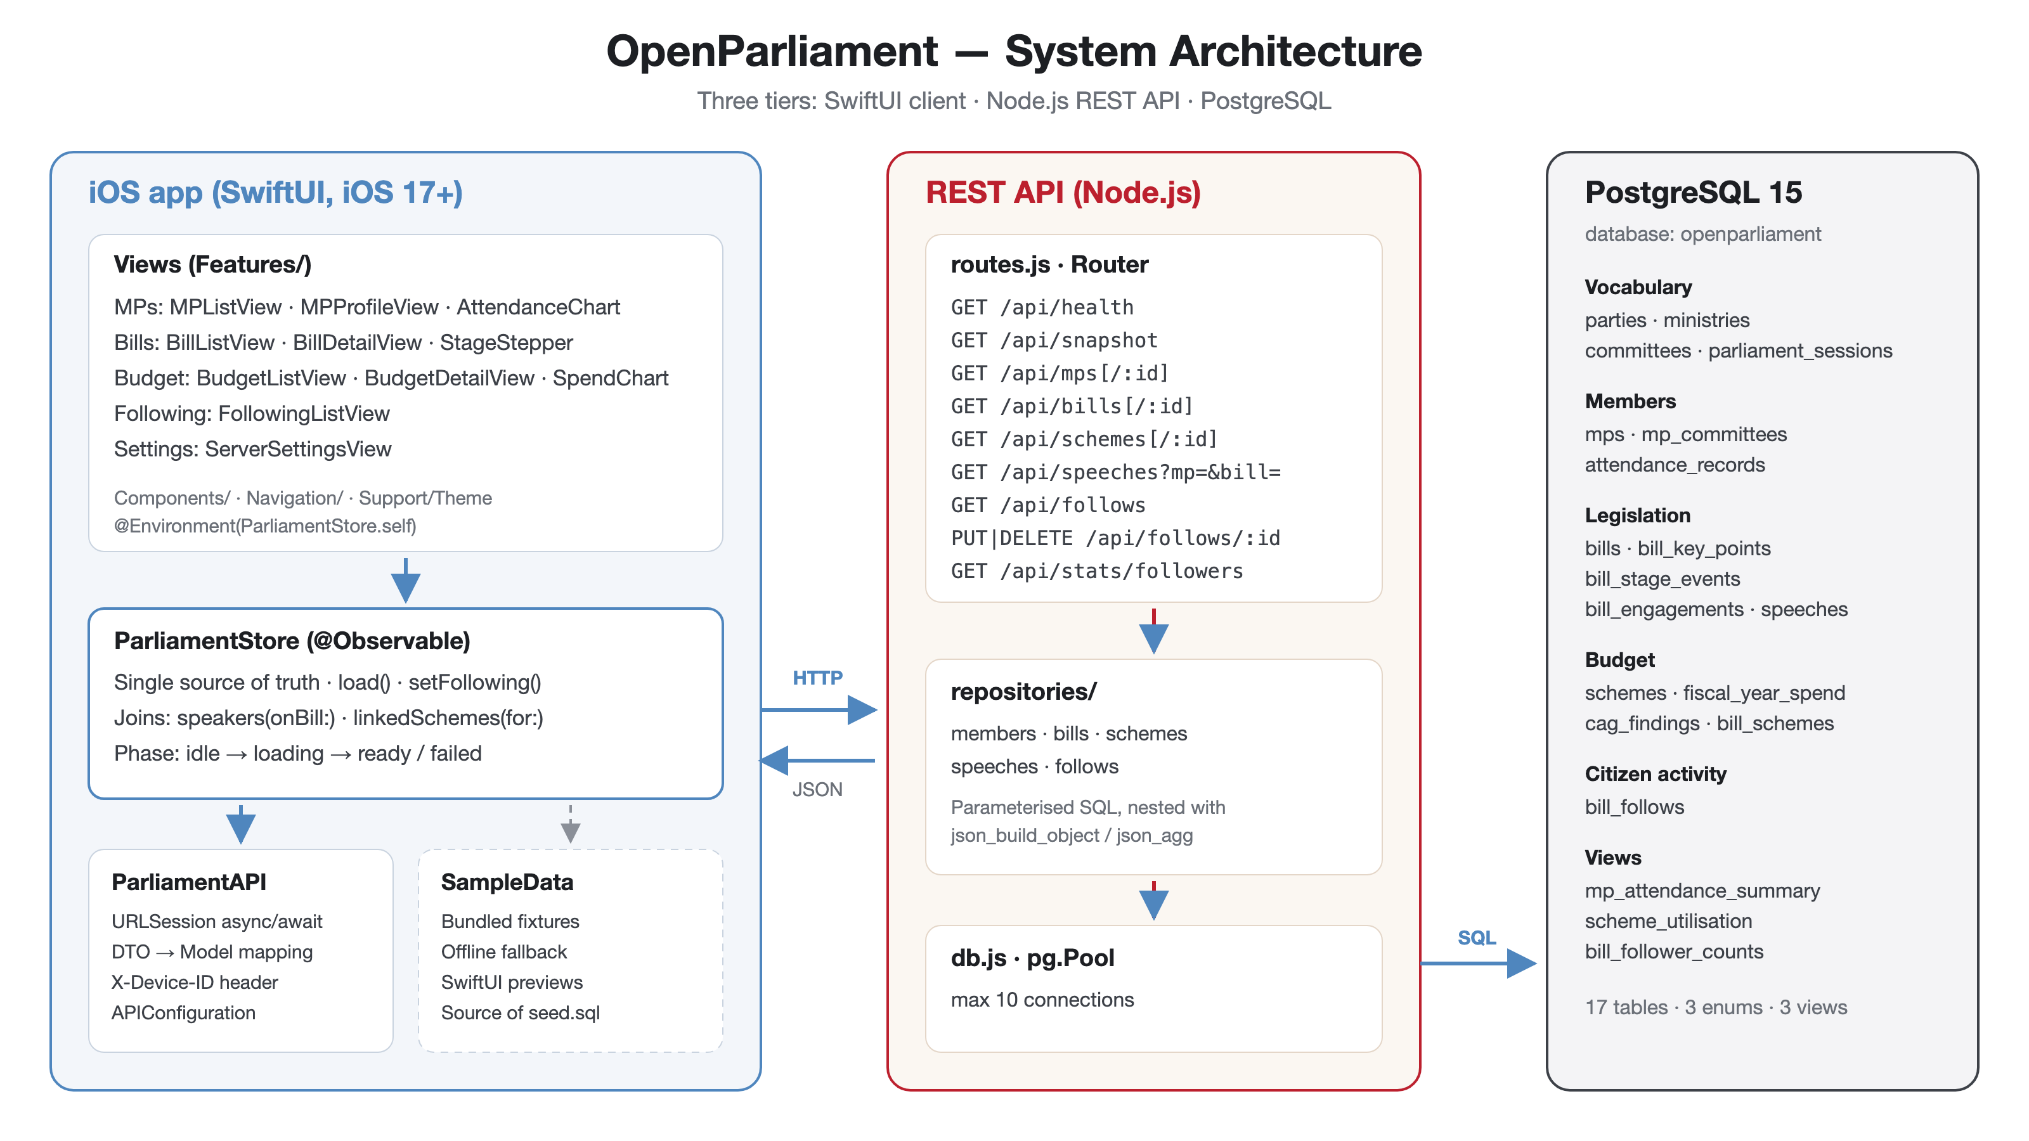
Fig. 1: System architecture
4.2 Data flow
At launch the store fetches the snapshot and the device's follows concurrently. The server builds each record, with its child rows already nested, in one SQL statement per collection. Following a bill updates the UI immediately and then writes through to the database; if the write fails, the change is rolled back and a notice is shown.
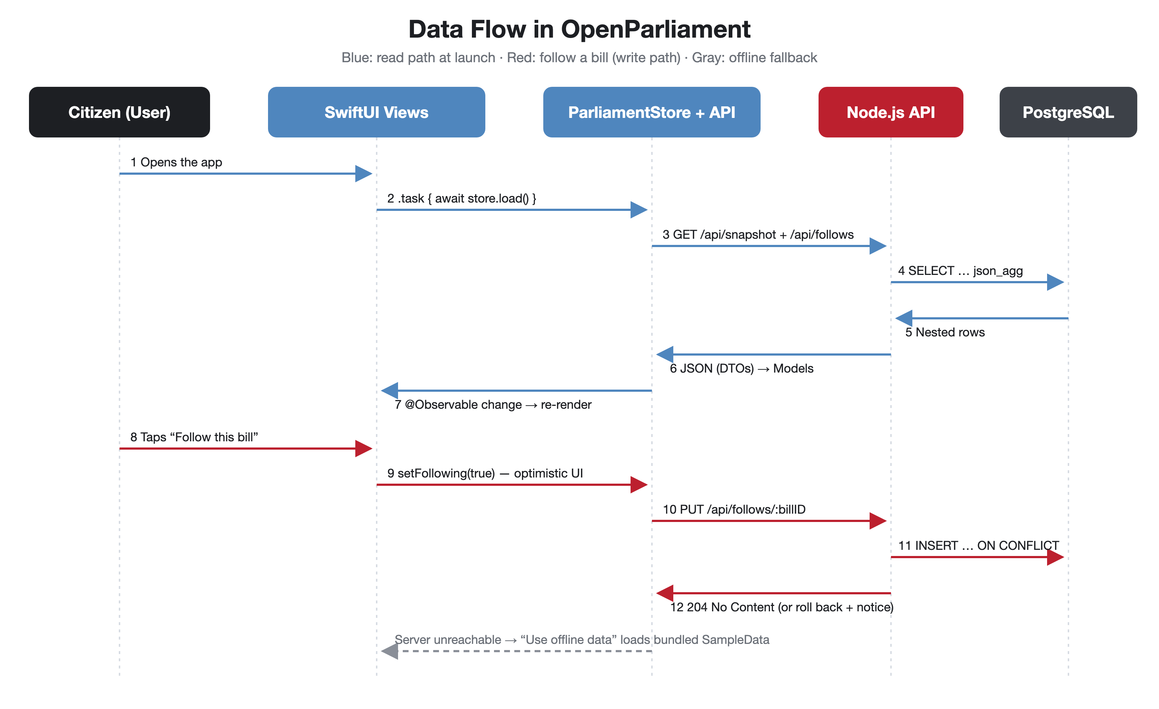
Fig. 2: Data flow for reading records and following a bill

4.3 Database design
The schema is in third normal form. Repeated vocabulary (parties, ministries, committees, sessions) is held in lookup tables; ordered lists such as key points and committee memberships carry an explicit position; derived figures (mean attendance, totals, utilisation) are computed in views and never stored.
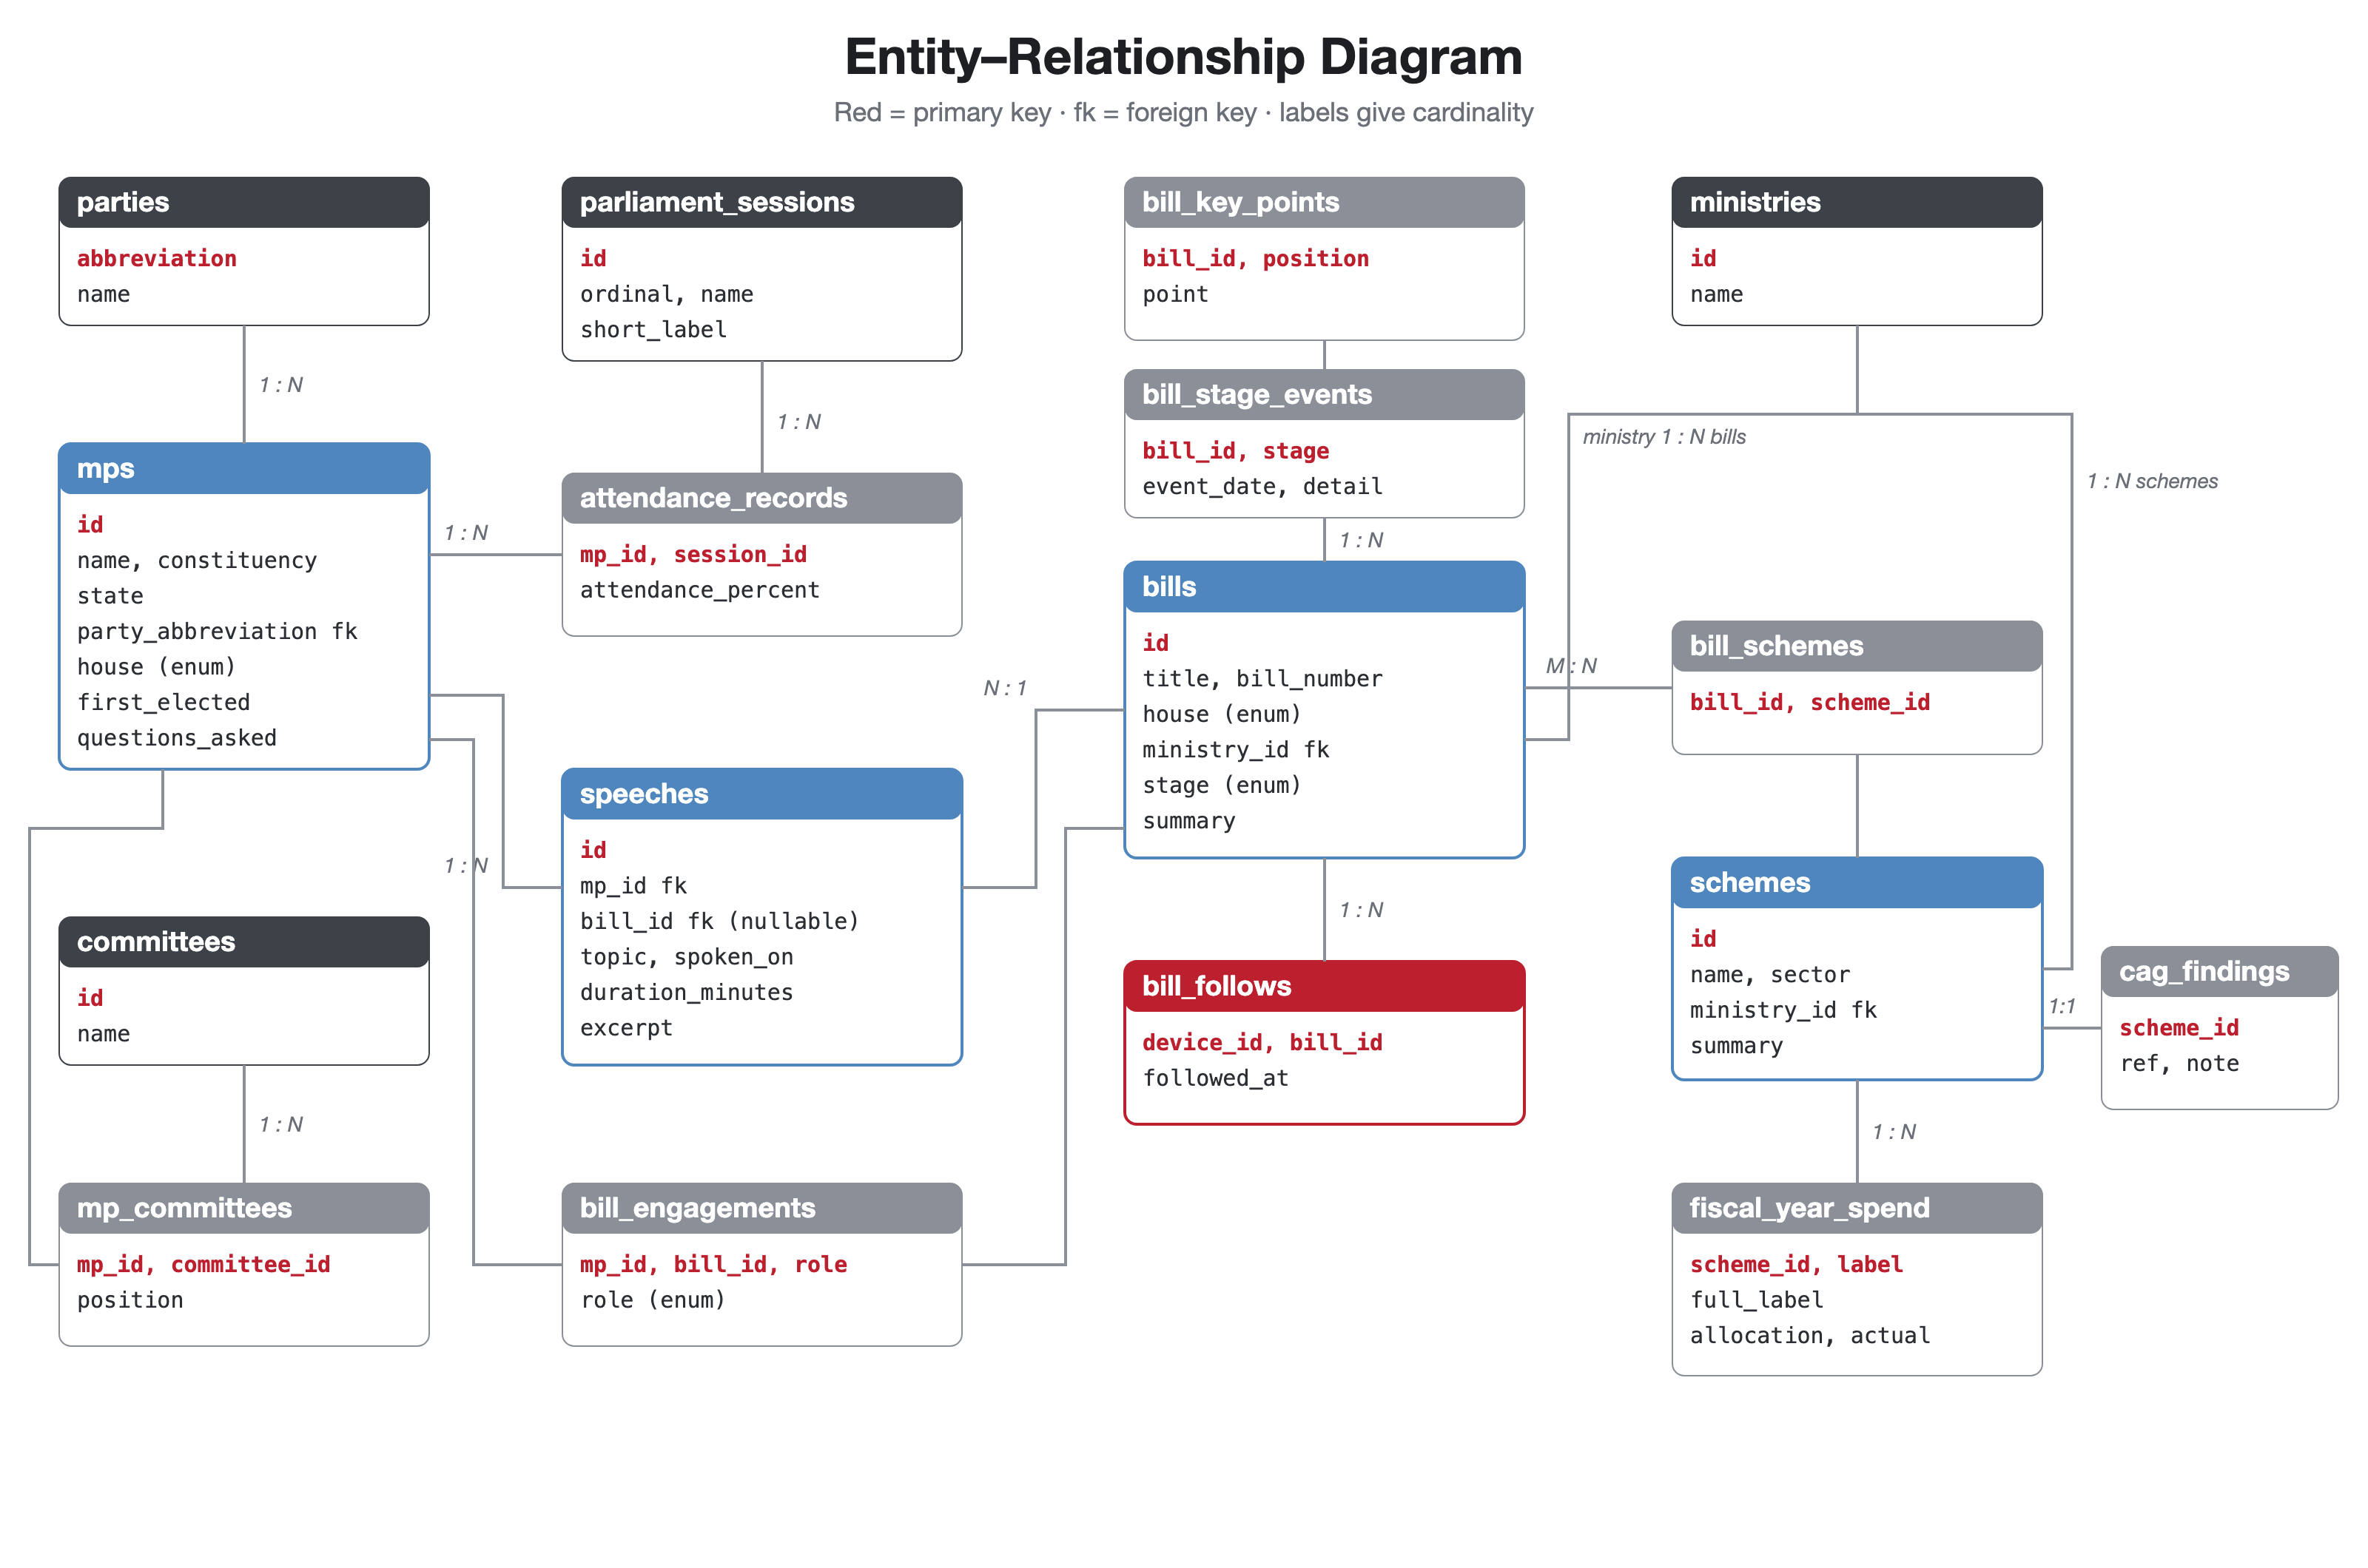
Fig. 3: Entity–relationship diagram
Table / View | Purpose | Key
parties, ministries, committees | Lookup vocabulary | abbreviation / id
parliament_sessions | Budget, Monsoon, Winter sittings in order | id (ordinal unique)
mps | Member identity, party, house, questions asked | id
mp_committees | Member ↔ committee (M:N) with display order | (mp_id, committee_id)
attendance_records | Attendance % per member per session | (mp_id, session_id)
bills | Title, number, house, ministry, current stage, summary | id
bill_key_points | Ordered plain-language points | (bill_id, position)
bill_stage_events | Dated history of each stage reached | (bill_id, stage)
bill_engagements | Sponsor / co-sponsor / committee / debated | (mp_id, bill_id, role)
speeches | Floor interventions, optionally on a bill | id
schemes | Budget scheme, sector, ministry | id
fiscal_year_spend | Allocation and actual spend per year (₹ crore) | (scheme_id, label)
cag_findings | Optional audit observation (1:1) | scheme_id
bill_schemes | Bill ↔ scheme (M:N) | (bill_id, scheme_id)
bill_follows | Bills followed by each device | (device_id, bill_id)
mp_attendance_summary (view) | Mean attendance per member | —
scheme_utilisation (view) | Totals, unspent and utilisation % | —
bill_follower_counts (view) | Followers per bill | —

4.4 REST API
Method | Endpoint | Description
GET | /api/health | Server and database status
GET | /api/snapshot | Members, bills, schemes and speeches in one response
GET | /api/mps, /api/mps/:id | Members with attendance, committees, engagements
GET | /api/bills, /api/bills/:id | Bills with key points, stage history, linked schemes
GET | /api/schemes, /api/schemes/:id | Schemes with yearly spend and audit finding
GET | /api/speeches?mp=&bill= | Speeches, optionally filtered
GET | /api/follows | Bills followed by the calling device (X-Device-ID)
PUT | /api/follows/:billID | Follow a bill (idempotent) → 204
DELETE | /api/follows/:billID | Unfollow a bill → 204
GET | /api/stats/followers | Follower count per bill

5. Implementation
5.1 Project structure
OpenParliament/
├── OpenParliament/ iOS app (Xcode project)
│ ├── App/ OpenParliamentApp, RootTabView
│ ├── Models/ MP, Bill, BudgetScheme, Speech, Vocabulary
│ ├── Data/
│ │ ├── ParliamentStore.swift @Observable store: loading, follows, joins
│ │ ├── Remote/ ParliamentAPI, DTOs, APIConfiguration, DeviceIdentity
│ │ └── Sample*.swift bundled fixtures (offline + previews + seed source)
│ ├── Features/ MPs/, Bills/, Budget/, Following/, Settings/
│ ├── Components/ Chrome/ (badges, stat tiles, banners), Rows/
│ ├── Navigation/ ParliamentDestinations (typed navigation)
│ └── Support/ Theme tokens, formatting extensions, button style
└── Server/
├── db/schema.sql, seed.sql, setup.sh
├── src/index.js, routes.js, http.js, db.js, config.js
├── src/repositories/ members, bills, schemes, speeches, follows
├── test/api.test.js end-to-end API tests
└── tools/ seed generator built from the app's fixtures

5.2 Database schema (excerpt)
CREATE TABLE bills (
id TEXT PRIMARY KEY,
title TEXT NOT NULL,
bill_number TEXT NOT NULL UNIQUE, -- "Bill No. 118 of 2025"
house house_name NOT NULL,
ministry_id INTEGER NOT NULL REFERENCES ministries (id),
stage bill_stage NOT NULL,
summary TEXT NOT NULL
);

CREATE TABLE bill_key_points (
bill_id TEXT NOT NULL REFERENCES bills (id) ON DELETE CASCADE,
position INTEGER NOT NULL,
point TEXT NOT NULL,
PRIMARY KEY (bill_id, position)
);

-- One dated row per stage a bill has reached.
CREATE TABLE bill_stage_events (
bill_id TEXT NOT NULL REFERENCES bills (id) ON DELETE CASCADE,
stage bill_stage NOT NULL,
event_date DATE NOT NULL,
detail TEXT NOT NULL,
PRIMARY KEY (bill_id, stage)
);

CREATE TABLE bill_engagements (
mp_id TEXT NOT NULL REFERENCES mps (id) ON DELETE CASCADE,
bill_id TEXT NOT NULL REFERENCES bills (id) ON DELETE CASCADE,
role engagement_role NOT NULL,
PRIMARY KEY (mp_id, bill_id, role)
);

-- A floor intervention. `bill_id` is NULL for zero hour, calling attention and
-- special mentions that are not tied to a bill.
CREATE TABLE speeches (
id TEXT PRIMARY KEY,
mp_id TEXT NOT NULL REFERENCES mps (id) ON DELETE CASCADE,
bill_id TEXT REFERENCES bills (id) ON DELETE SET NULL,
topic TEXT NOT NULL,
spoken_on DATE NOT NULL,
duration_minutes INTEGER NOT NULL CHECK (duration_minutes > 0),
excerpt TEXT NOT NULL
);

CREATE INDEX speeches_mp_idx ON speeches (mp_id, spoken_on DESC);
CREATE INDEX speeches_bill_idx ON speeches (bill_id, spoken_on DESC);

CREATE VIEW scheme_utilisation AS
SELECT
s.id AS scheme_id,
s.name,
SUM(f.allocation_crore) AS total_allocation,
SUM(f.actual_crore) AS total_actual,
SUM(f.allocation_crore) - SUM(f.actual_crore) AS unspent,
ROUND(100 * SUM(f.actual_crore) / NULLIF(SUM(f.allocation_crore), 0), 1) AS utilisation_percent
FROM schemes s
JOIN fiscal_year_spend f ON f.scheme_id = s.id
GROUP BY s.id, s.name;

5.3 Server: nested JSON built in SQL
Each repository returns a fully-formed record using json_build_object and correlated json_agg subqueries, so the API layer stays thin and the app receives exactly the shape of its models.
const BILL_SELECT = `
SELECT json_build_object(
'id', b.id,
'title', b.title,
'billNumber', b.bill_number,
'house', b.house,
'ministry', mi.name,
'stage', b.stage,
'summary', b.summary,
'keyPoints', COALESCE((
SELECT json_agg(k.point ORDER BY k.position)
FROM bill_key_points k
WHERE k.bill_id = b.id
), '[]'::json),
'stageHistory', COALESCE((
SELECT json_agg(json_build_object(
'stage', se.stage,
'date', to_char(se.event_date, 'YYYY-MM-DD'),
'detail', se.detail
) ORDER BY se.stage)
FROM bill_stage_events se
WHERE se.bill_id = b.id
), '[]'::json),
'linkedSchemeIDs', COALESCE((
SELECT json_agg(bs.scheme_id ORDER BY bs.scheme_id)
FROM bill_schemes bs
WHERE bs.bill_id = b.id
), '[]'::json)
) AS bill
FROM bills b
JOIN ministries mi ON mi.id = b.ministry_id

.put('/api/follows/:billID', async ({ request, params }) => {
const device = deviceID(request);
if (!(await bills.billExists(params.billID))) throw new HTTPError(404, 'Bill not found');
await follows.follow(device, params.billID);
return [204];
})

5.4 App: the observable store
ParliamentStore is created once in OpenParliamentApp and injected with .environment(store). Every screen reads it with @Environment(ParliamentStore.self), so a follow made on a bill's page appears instantly in the Following tab and its badge.
func load() async {
guard phase != .loading else { return }
let hadContent = hasContent
phase = .loading

do {
async let snapshot = api.snapshot()
async let follows = api.followedBillIDs()
let (payload, followed) = try await (snapshot, follows)

mps = try payload.mps.map { try $0.toModel() }
bills = try payload.bills.map { try $0.toModel() }
schemes = payload.schemes.map { $0.toModel() }
speeches = try payload.speeches.map { try $0.toModel() }
followedBillIDs = followed
source = .server
lastSynced = .now
notice = nil
phase = .ready
} catch {
if hadContent {
notice = error.localizedDescription
phase = .ready
} else {
phase = .failed(error.localizedDescription)
}
}
}

/// Continues without the server, on the records bundled with the app.

func setFollowing(_ follow: Bool, bill: Bill) async {
guard follow != isFollowing(bill) else { return }
let previous = followedBillIDs
if follow {
followedBillIDs.insert(bill.id, at: 0)
} else {
followedBillIDs.removeAll { $0 == bill.id }
}

guard source == .server else { return }
do {
if follow {
try await api.follow(billID: bill.id)
} else {
try await api.unfollow(billID: bill.id)
}
} catch {
followedBillIDs = previous
notice = "Couldn’t save that change. \(error.localizedDescription)"
}
}

// MARK: - Lookups

5.5 App: networking and DTO mapping
private func perform(_ request: URLRequest) async throws -> Data {
let data: Data
let response: URLResponse
do {
(data, response) = try await session.data(for: request)
} catch {
throw APIError.unreachable(baseURL)
}
guard let http = response as? HTTPURLResponse else { throw APIError.unreachable(baseURL) }
guard (200..<300).contains(http.statusCode) else { throw APIError.status(http.statusCode) }
return data
}

private func send<Response: Decodable>(_ method: String, _ path: String) async throws -> Response {
let data = try await perform(request(method, path))
do {
return try JSONDecoder().decode(Response.self, from: data)
} catch {
throw APIError.decoding(error)
}
}

private func sendWithoutBody(_ method: String, _ path: String) async throws {

extension BillDTO {
func toModel() throws -> Bill {
Bill(
id: id,
title: title,
billNumber: billNumber,
house: try House(code: house),
ministry: ministry,
stage: try BillStage(code: stage),
summary: summary,
keyPoints: keyPoints,
stageHistory: try stageHistory.map {
StageEvent(stage: try BillStage(code: $0.stage), date: try ServerDate.parse($0.date), detail: $0.detail)
},
linkedSchemeIDs: linkedSchemeIDs
)
}
}

extension SchemeDTO {

5.6 App: wiring a view to the store
struct BillDetailView: View {
let bill: Bill
@Environment(ParliamentStore.self) private var store

private var interventions: [Speech] { store.interventions(onBill: bill.id) }
private var speakers: [MP] { store.speakers(onBill: bill.id) }
private var linkedSchemes: [BudgetScheme] { store.linkedSchemes(for: bill) }

var body: some View {

private var isFollowing: Binding<Bool> {
Binding(
get: { store.isFollowing(bill) },
set: { newValue in Task { await store.setFollowing(newValue, bill: bill) } }
)
}

private func interventionNote(for mp: MP) -> String {

6. Output (Screenshots)
Screenshots of the application running on the iPhone 17 Pro simulator (iOS 26.5), with data served from the local PostgreSQL database through the Node.js API.
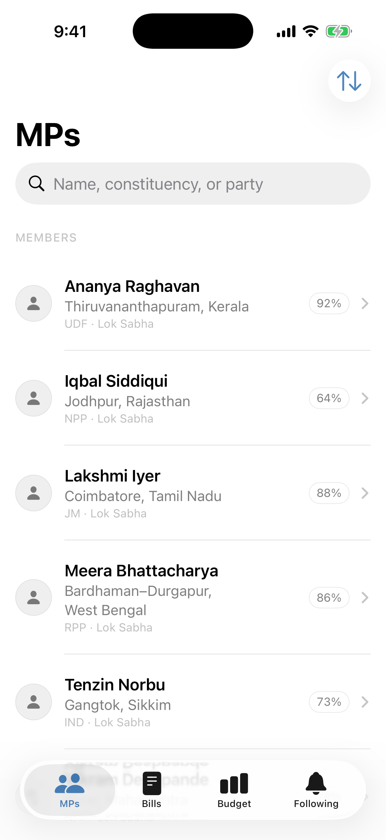 | 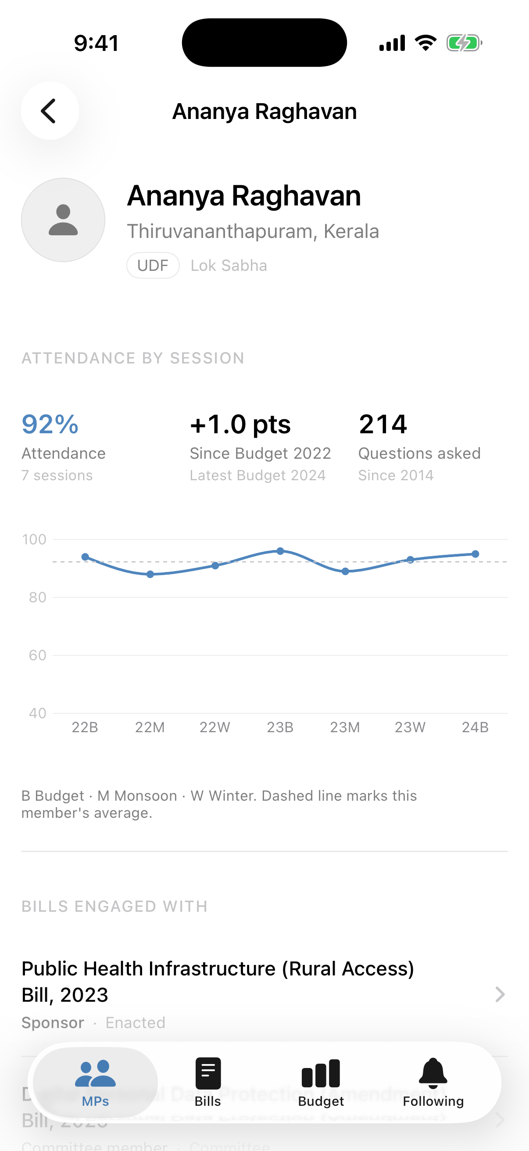
Fig. 4: MPs list (search, sort, attendance) | Fig. 5: MP profile with attendance chart

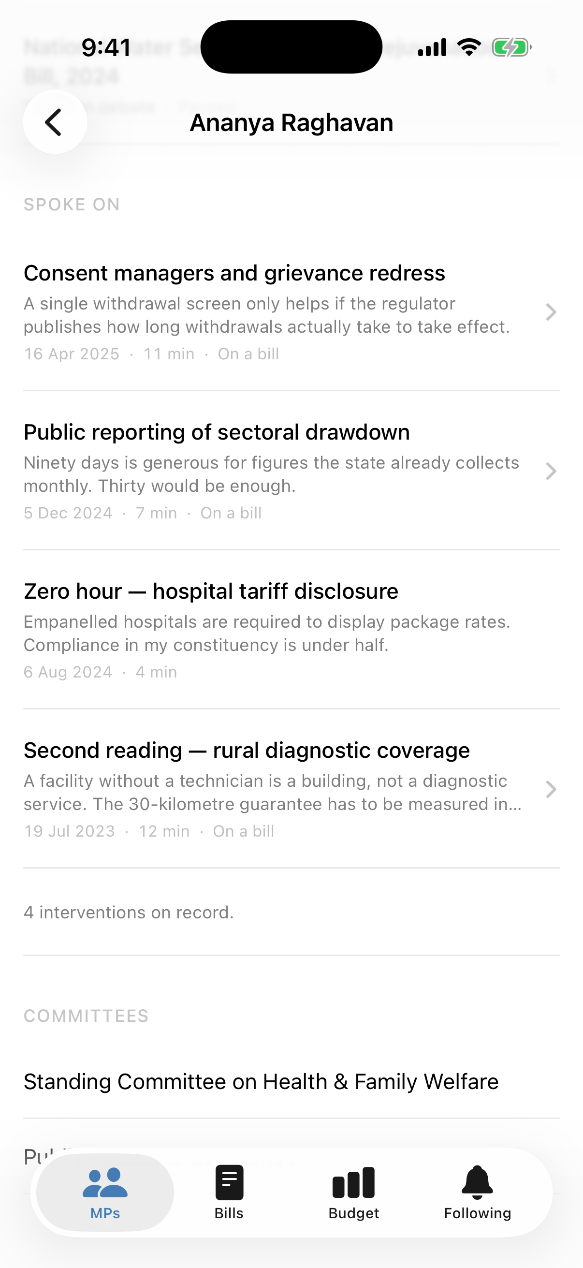 | 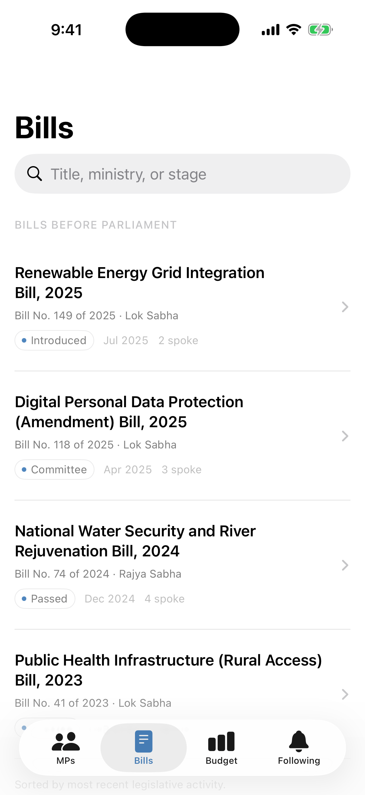
Fig. 6: MP speeches and committees | Fig. 7: Bills before Parliament

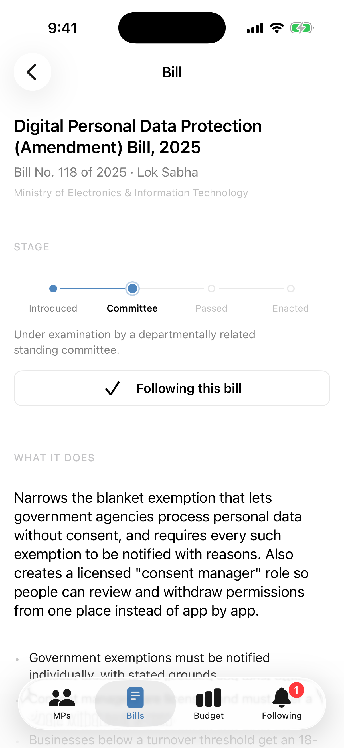 | 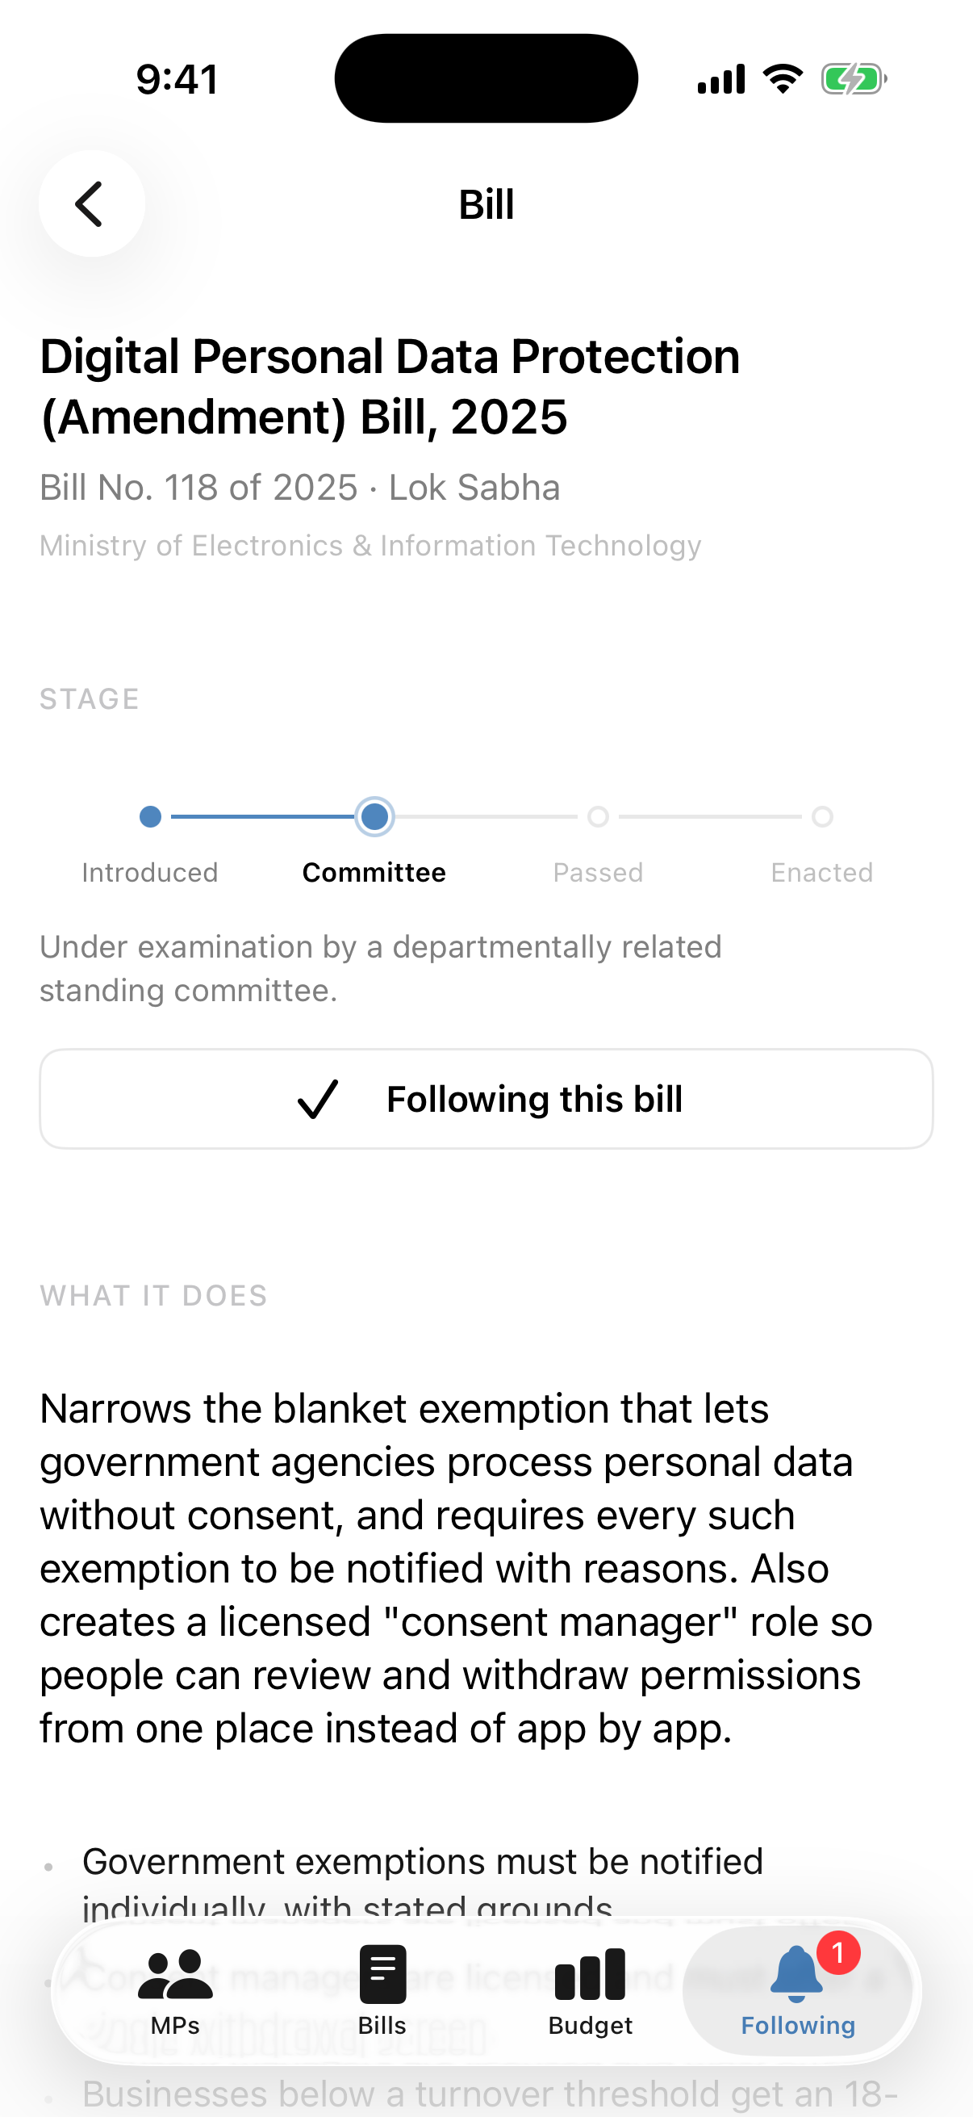
Fig. 8: Bill detail with stage stepper | Fig. 9: Bill followed (saved to database)

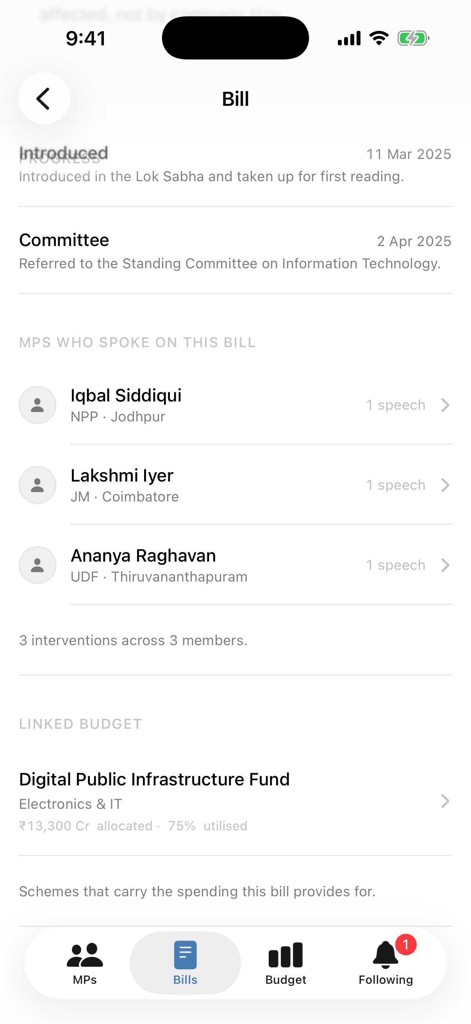 | 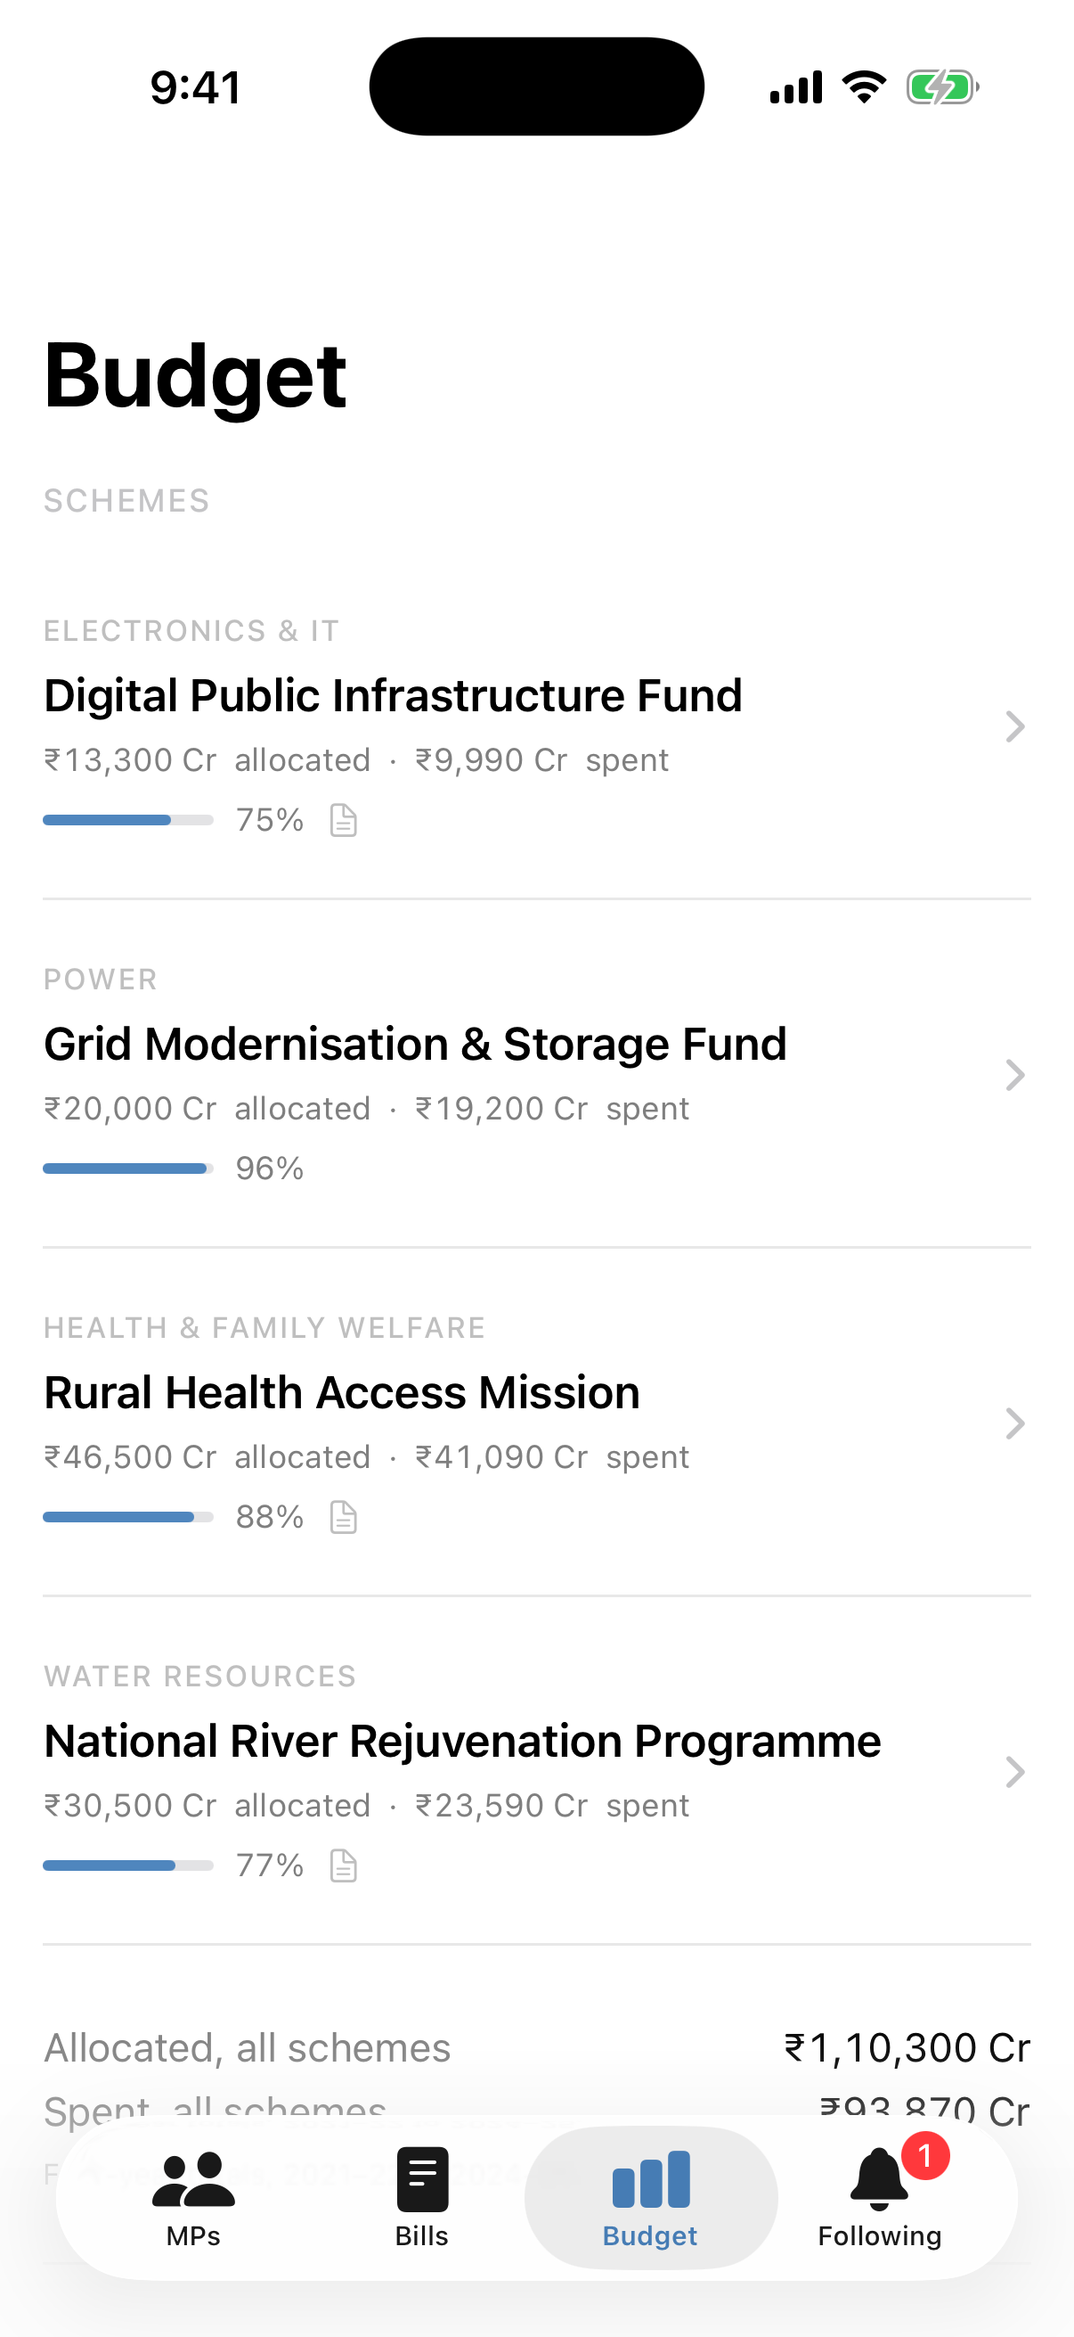
Fig. 10: Key points and dated progress | Fig. 11: Speakers and linked budget

 | 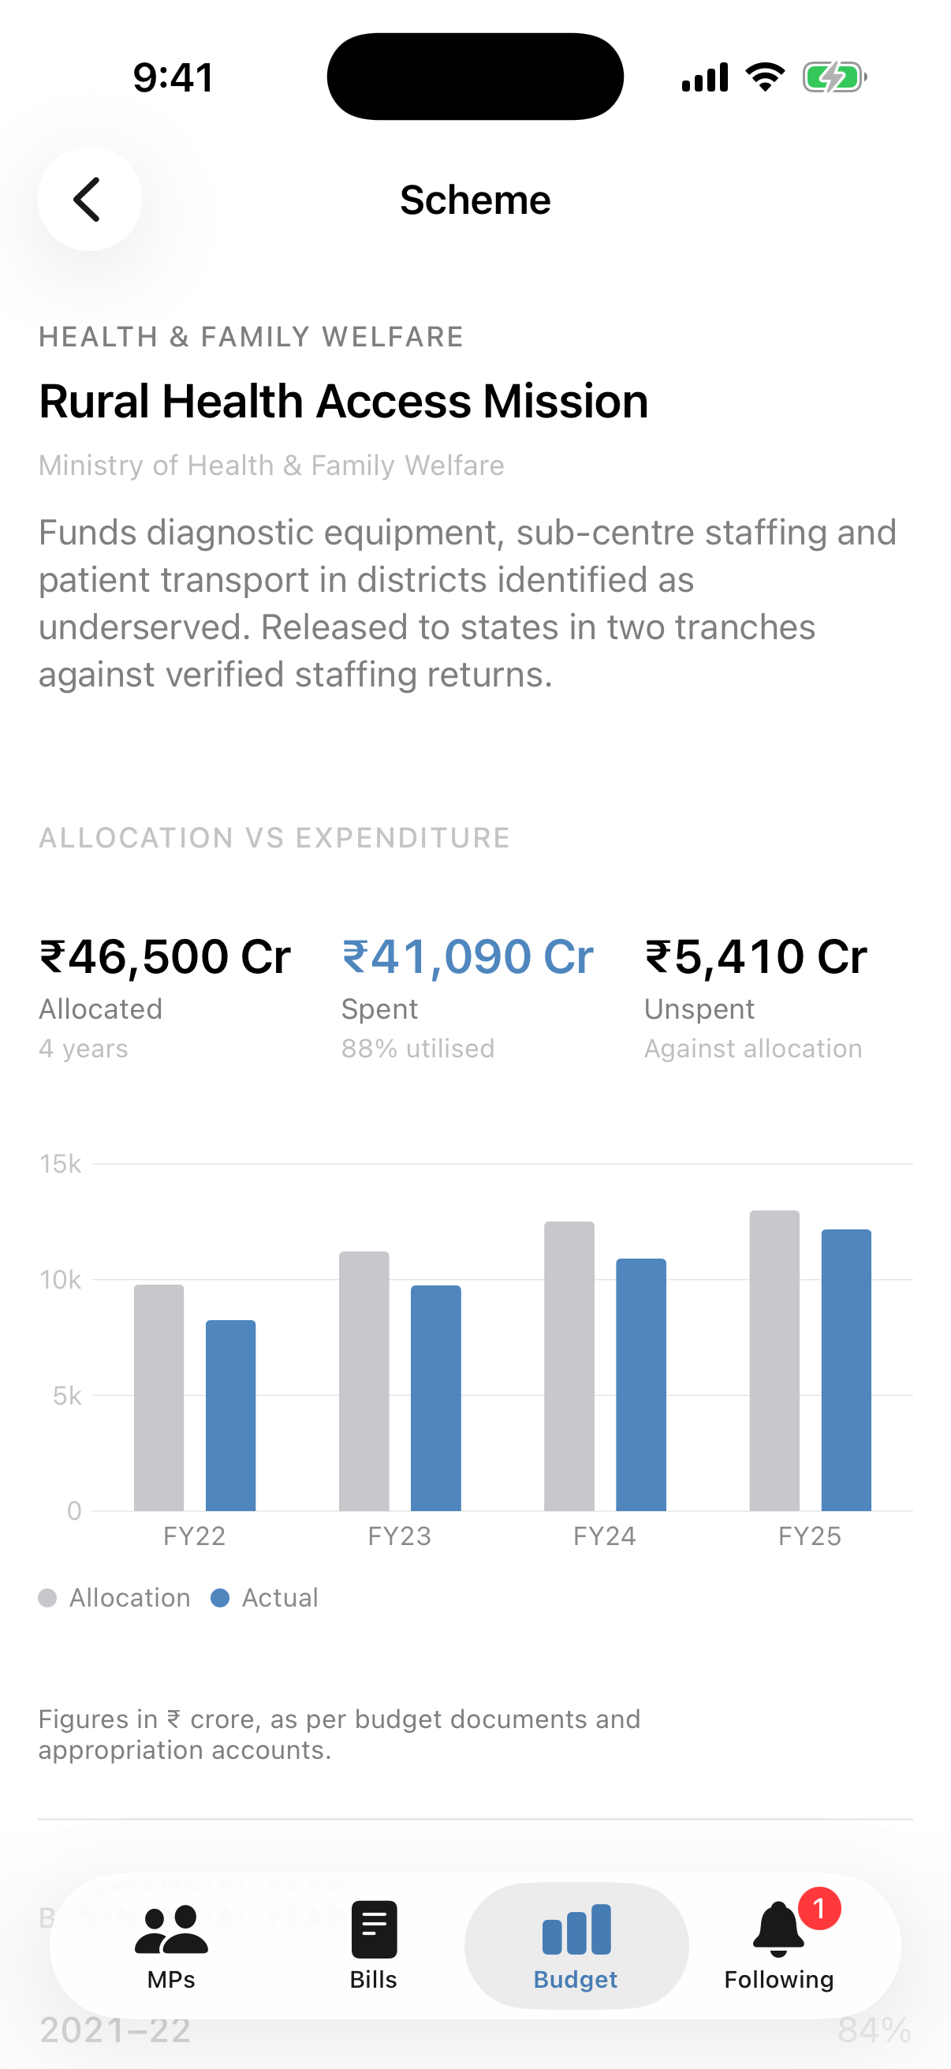
Fig. 12: Budget schemes with utilisation | Fig. 13: Allocation vs. expenditure chart

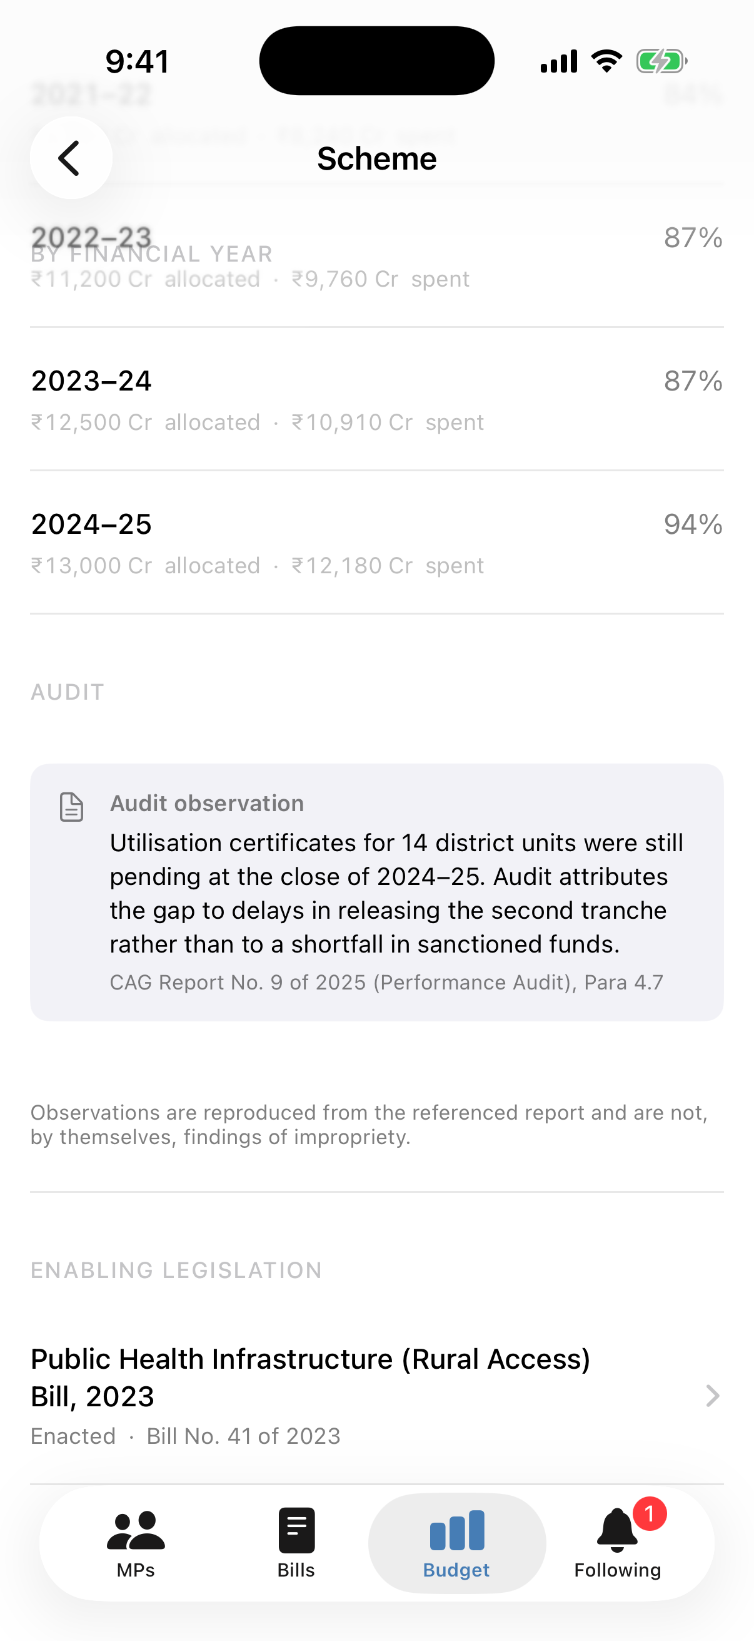 | 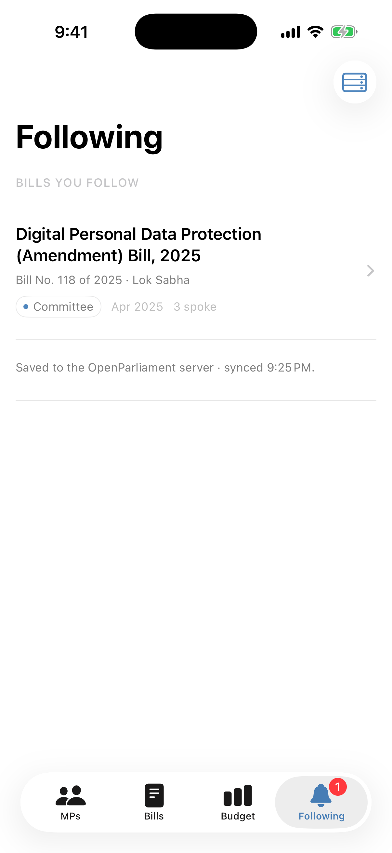
Fig. 14: Year-wise spend and CAG audit note | Fig. 15: Following tab

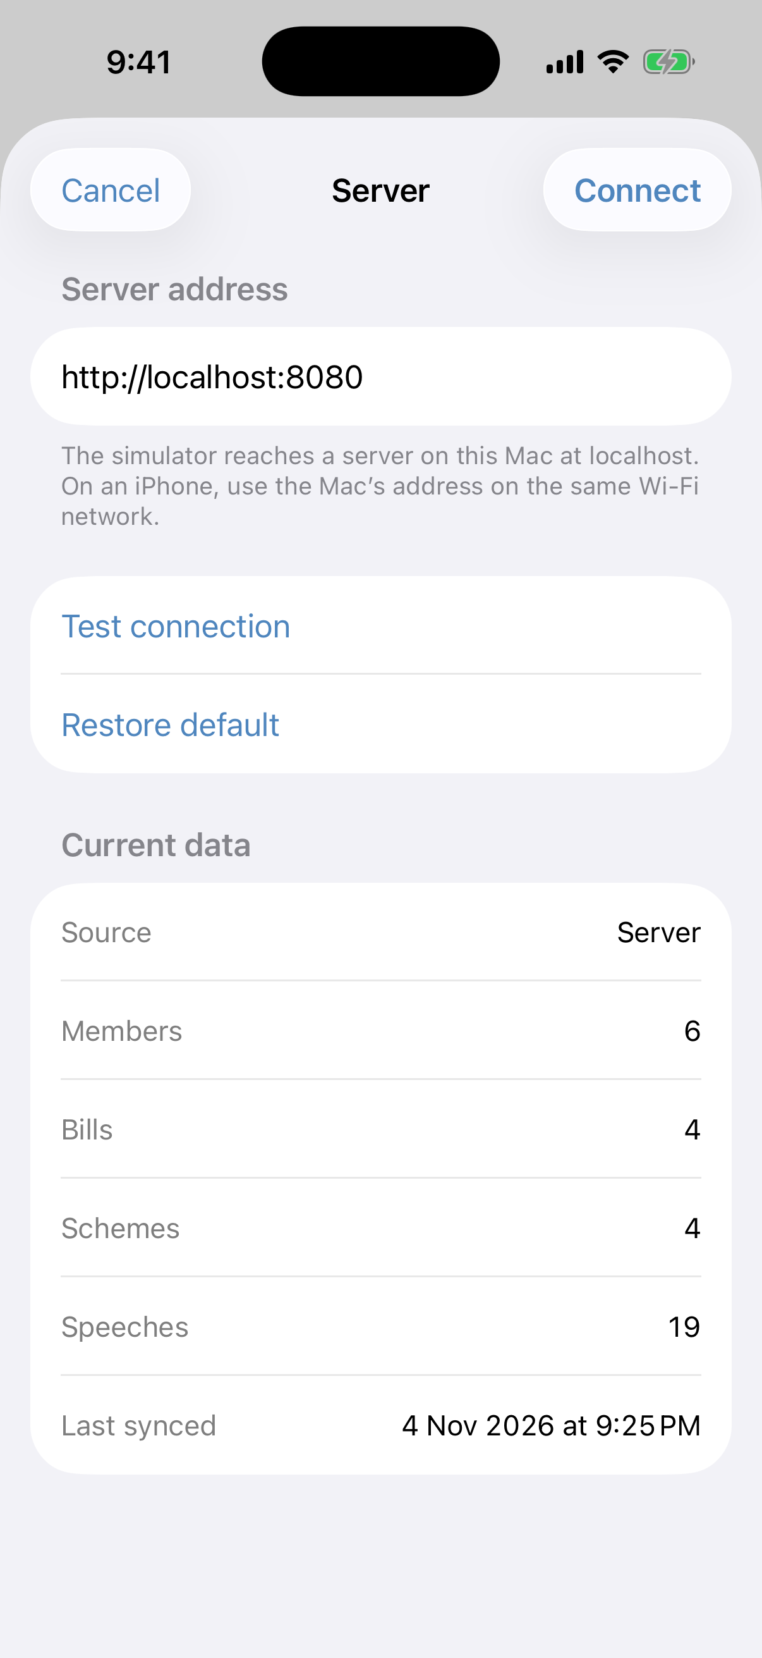 | 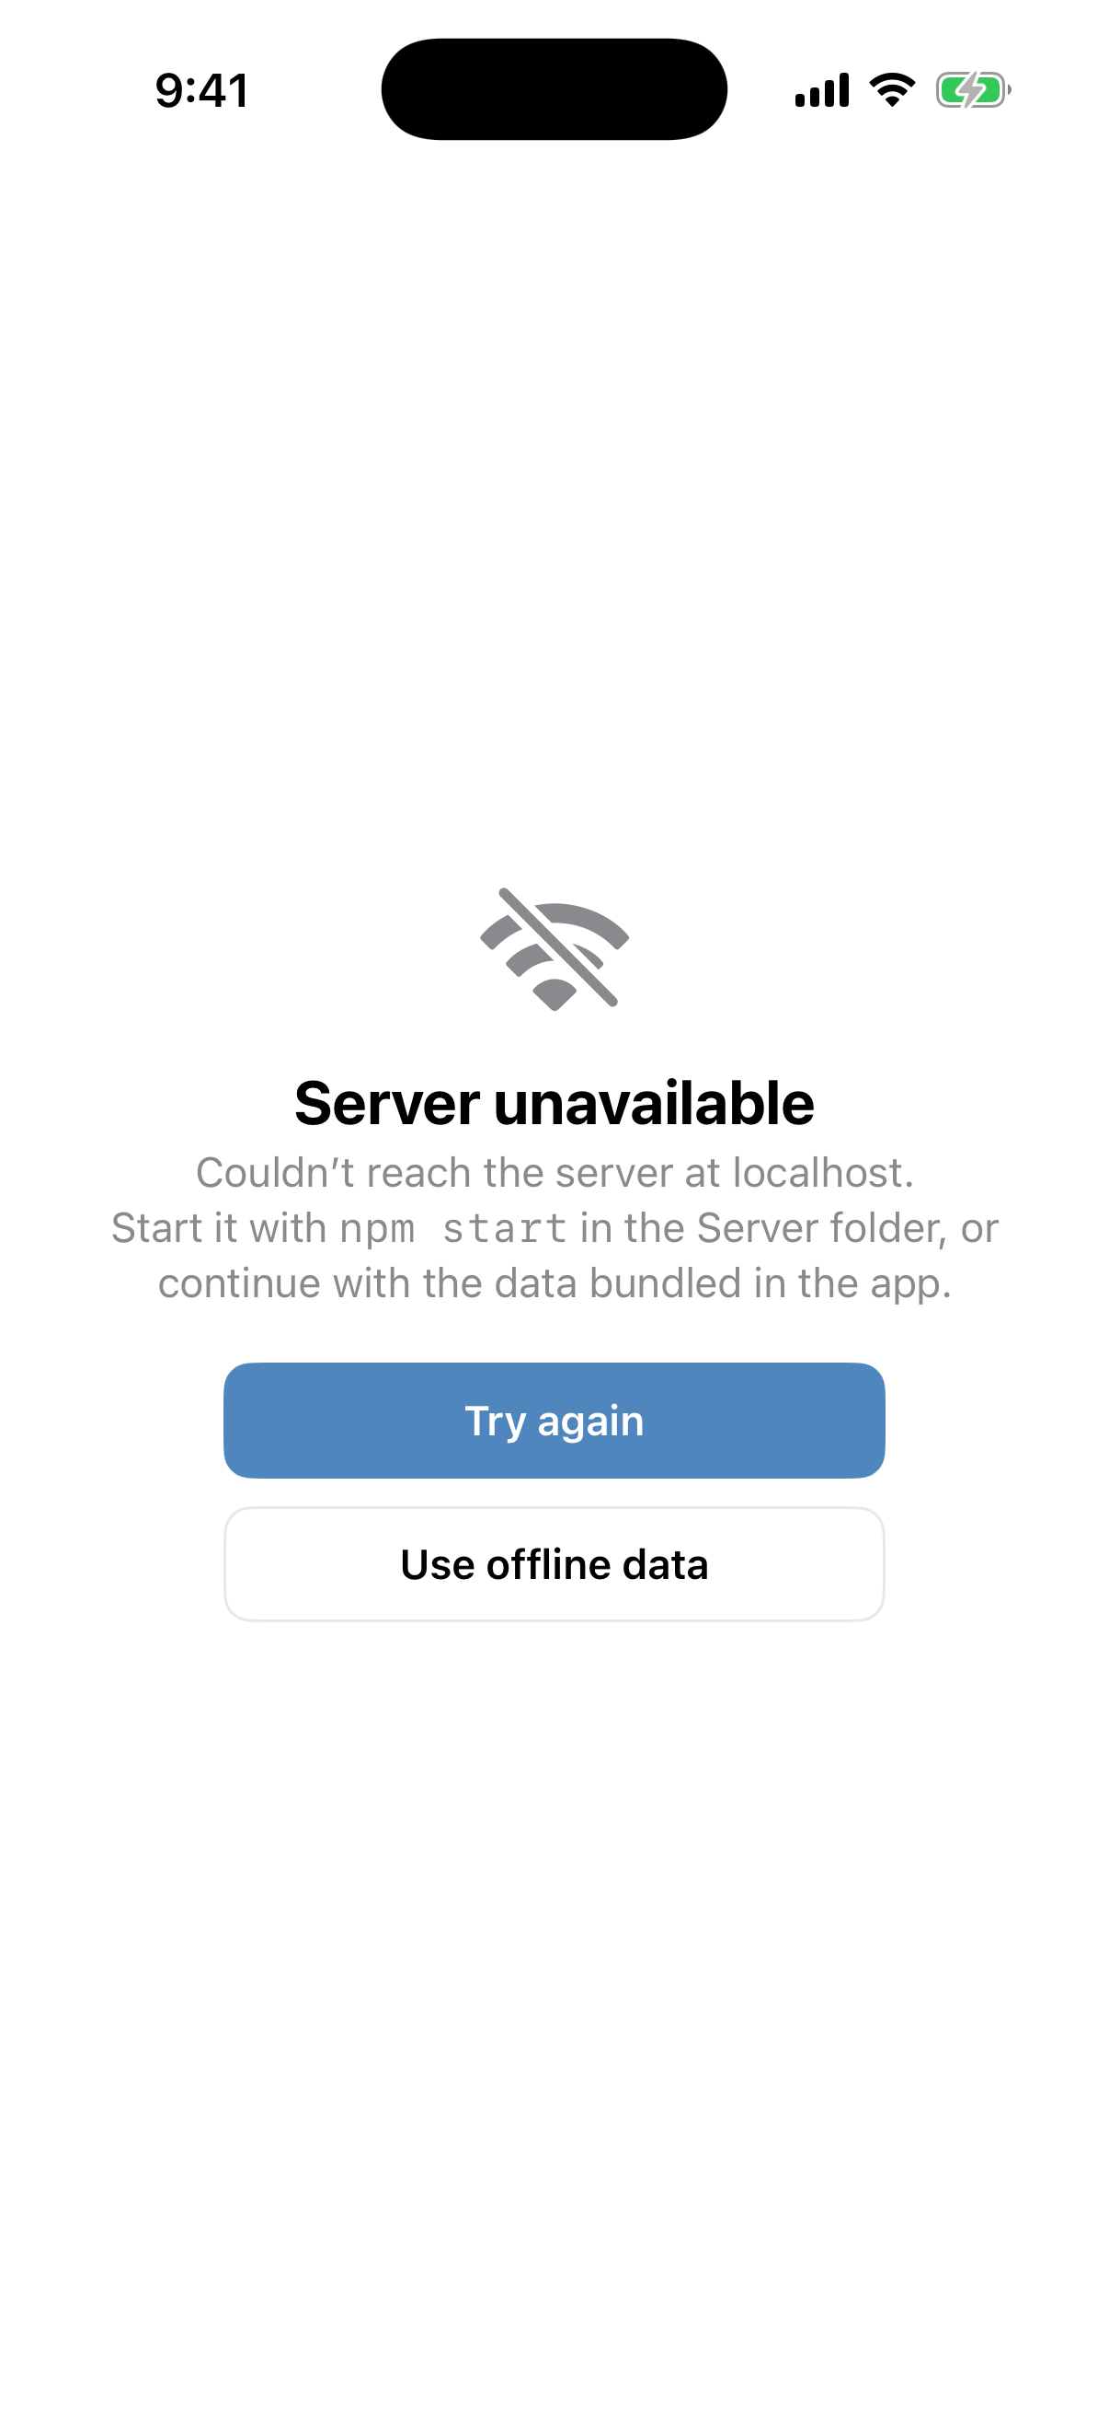
Fig. 16: Server settings and data summary | Fig. 17: Server unavailable state

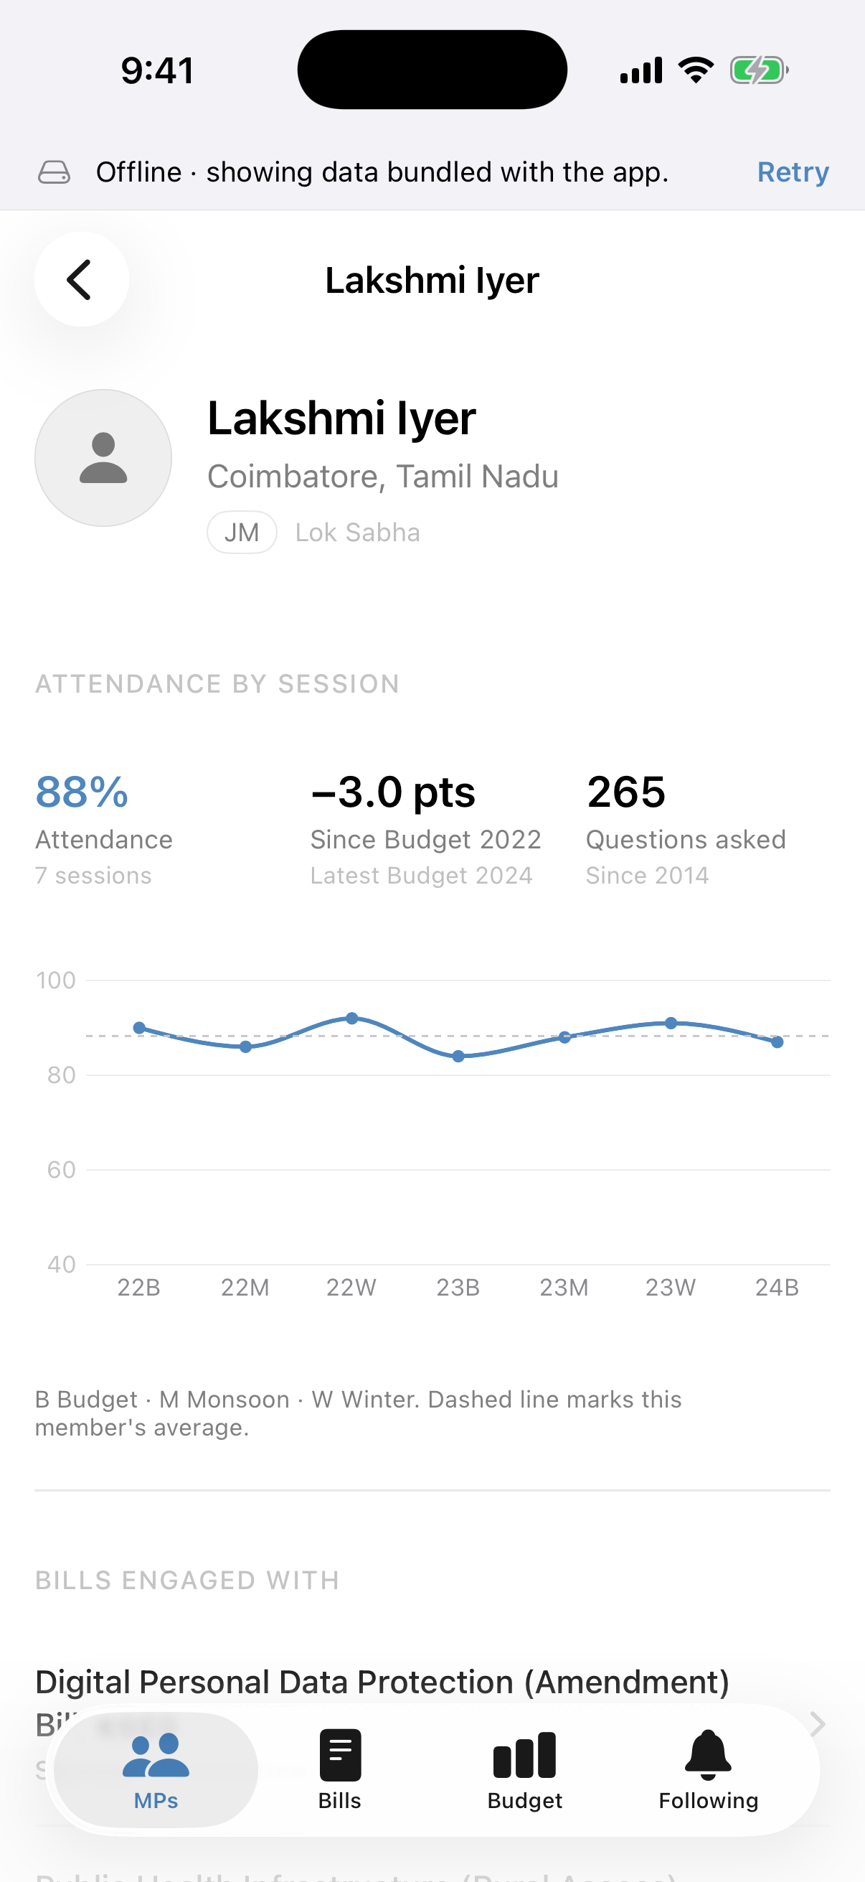
Fig. 18: Offline mode with bundled data

6.1 Database after following a bill from the app
device_id | bill_id | followed_at
--------------------------------------+-----------+----------------------------------
b9253f3a-c581-4c86-ad2a-f6a6321ceddd | bill-dpdp | 2026-11-04 21:27:09.761784+05:30
(1 row)

7. Testing
7.1 Automated API tests (node --test)
# | Test | Result
1 | Health reports a connected database | Pass
2 | Snapshot returns every collection with nested records | Pass
3 | Unknown records and routes return 404 | Pass
4 | Speeches filter by member | Pass
5 | Follow and unfollow round-trip through the database (idempotent) | Pass
6 | Follow requests without a valid X-Device-ID are rejected (400) | Pass

7.2 Manual test cases on the simulator
# | Action | Expected | Observed
1 | Launch app with server running | Lists load from API, no banner | As expected
2 | Search MPs for “Kerala” | Only matching member shown | As expected
3 | Sort MPs by attendance | Descending attendance order | As expected
4 | Tap Follow this bill | Button changes; row in bill_follows | As expected (Sec. 6.1)
5 | Open Following tab | Followed bill listed, badge = 1 | As expected
6 | Swipe left → Unfollow | Row removed from list and database | As expected
7 | Stop server, relaunch | Server unavailable screen | As expected
8 | Tap Use offline data | Bundled data with offline banner | As expected
9 | Tap a speaker on a bill | Pushes that member's profile | As expected
10 | Tap linked scheme on a bill | Pushes the scheme detail | As expected

8. Conclusion
OpenParliament was extended from a static SwiftUI prototype into a complete product backed by a local PostgreSQL database. The database models members, legislation and budgets in third normal form with constraints and derived views; a small Node.js API serves nested JSON built directly in SQL; and the app consumes it through an observable store with asynchronous networking, optimistic writes, error states and an offline fallback. The project shows how SwiftUI's declarative views, the Observation framework and Swift Charts combine with a relational backend to present public records in a clear, linked and trustworthy way.
Future Scope
• Import real records from official open-data sources on a schedule.
• Push notifications when a followed bill changes stage.
• User accounts with sync of follows across devices, and comment threads on bills.
• Full-text search in PostgreSQL (tsvector) across speeches and bill summaries.
• Deploy the API with HTTPS and authentication for use beyond the local network.

